

Vile Parle (West), Mumbai – 400056
PROJECT REPORT ON

Submitted in parallel Fulfilment of Requirements

The Diploma in Computer Engineering/ Information Technology

Name of Student:

Roll No:

SAP No:

Academic Year:

Name of Department:

Year/Semester:

THIS IS TO CERTIFY THAT

Shri/ Smt. / Kum

Exam Seat No

Has Satisfactorily Completed His/her Project work and submitted

Guide Head of Dept Principal Date:

Vile Parle (West), Mumbai – 400056

PROJECT APPROVAL SHEET

THIS IS TO CERTIFY THAT

Shri/ Smt. / Kum.

SAP No. has Presented a Project Entitled

In Partial Fulfilment of

Diploma in Computer Engineering/Information Technology Same is Approved by:
- External Examiner Name and Sign

- Internal Examiner
Name and Sign

Date:

Information Technology Department
Vision
To create a learning environment that nurtures students and transform them into competent IT Diploma Graduates.

Mission
M1: To impart technical and managerial skills for pursuing academic excellence through dynamic learning environment.
M2: To foster industry ready graduates by acquiring and utilizing latest technology.
M3: To strengthen holistic development and Professionalism in the Diploma graduates.
Program Educational Objectives (PEO’s)

After successful completion of the program students will be able to:

PEO1: Imbibe core knowledge and utilize associated technologies to provide domain related solutions.
PEO2: Be capable of adapting to the rapid pace of technological dynamics through professional competence.
PEO3: Develop a holistic personality equipped with leadership qualities, team skills and humane approach towards society.

Program Specific Outcomes (PSO’s)
PSO1: Students will demonstrate fundamental knowledge in core domains of IT such as Software Development, Databases and Information Systems
PSO2: Students will acquire skills that can provide IT solutions in the field of Networking, IOT, Machine Learning and Cloud Computing.

Abstract
MKES CARE+ is an integrated clinic management application designed to streamline the daily operations of eye and dental clinics. The application provides patient and appointment management functionalities to organize patient records, schedule consultations, and track patient visits efficiently. It offers comprehensive staff management features, including attendance tracking, shift management, task assignments, leave management, and performance monitoring. The system also supports inventory and vendor management, enabling clinic administrators to monitor stock availability, track product expiry dates, and manage medical and optical supplies. To simplify administrative and financial operations, MKES CARE+ incorporates optical sales management, dental laboratory tracking, billing, invoice generation, and financial reporting. Furthermore, the application integrates WhatsApp automation to facilitate appointment reminders, patient follow-ups, annual eye check-up reminders, dental treatment follow-ups, and notifications regarding spectacles and dental laboratory orders. With role-based access control, centralized information management, and administrative dashboards, MKES CARE+ aims to reduce manual effort, improve coordination among clinic staff, enhance record management, and increase the overall efficiency of clinic operations.

Table of Contents

Abstract 5
Chapter 1 9
  - Problem Statement 9
  - Introduction 10
Chapter 2 11
  - Requirements 11
    - Server Requirements 11
    - Client Requirements 11
  - Technologies Used 12
    - Flutter 12
    - Android Studio 13
    - Supabase 13
    - PostgreSQL 14
  - Features 16
  - Gantt Chart 16
Chapter 3 17
  - SYSTEM DESIGN 17
    - Flowchart 17
    - DFD Level 0: 18
    - DFD Level 1: 18
    - Use Case Diagram 19
    - Basic Architecture 19
Chapter 4 20
  - Literature Review 20
  - Source Code 26
  - Snapshots 48
Chapter 5 66
  - Advantages 66
  - Future Scope 67
  - Limitations 68
  - Acknowledgement 69
  - Conclusion 70
  - References 71

Figures
Figure 1 Flutter Logo 12
Figure 2 Android Studio Logo 13
Figure 3 Supabase Logo 13
Figure 4 PostgreSQL Logo 14
Figure 6 Gantt Chart 16
Figure 7 Flow Chart 17
Figure 8 Level 0 DFD 18
Figure 9 Level 1 DFD 18
Figure 10 Use Case Diagram 19
Figure 11 Basic Architecture 19
Figure 12 Sign in 48
Figure 13 Successful Creation 49
Figure 14 Email Log 50
Figure 15 OTP Login 49
Figure 16 Home Screen 50
Figure 17 Disease Detection 51
Figure 18 Detected Disease 52
Figure 19 Farmer's Market 53
Figure 20 Sell Produce Screen 54
Figure 21 Farmer's produce 55
Figure 22 View Produce 56
Figure 23 Search Functionality 57
Figure 24 Commodity Prices 58
Figure 25 Viewing the prices 59
Figure 26 Government Schemes 60
Figure 27 Searching Schemes 61
Figure 28 Government Scheme Details 62
Figure 29 Model Accuracy 63
Figure 30 User Collection 63
Figure 31 Produce Collection 64
Figure 32 Account Page 64
Figure 33 Plant Disease Dataset 65

Chapter 1

Problem Statement

Managing the daily operations of an eye and dental clinic can be challenging due to the reliance on manual processes and disconnected systems for handling patient records, appointments, staff attendance, inventory, billing, and communication. These inefficiencies can lead to data duplication, scheduling conflicts, attendance tracking errors, delays in patient follow-ups, and difficulties in monitoring stock levels and financial performance. Furthermore, the absence of centralized information makes it difficult for clinic administrators to coordinate staff activities, manage dental laboratory orders, track optical sales, and make informed operational decisions. Limited automation of routine tasks increases administrative workload and reduces overall operational efficiency. The lack of a unified, user-friendly platform that integrates clinic management, automated communication, and reporting creates significant challenges in maintaining organized workflows and delivering efficient patient services. Therefore, there is a need for an integrated clinic management system, MKES CARE+, that streamlines administrative operations, improves information accessibility, enhances coordination among clinic staff, and supports efficient management of eye and dental clinics.

Introduction
In today's healthcare environment, managing the daily operations of clinics efficiently has become increasingly important. Eye and dental clinics handle various activities, including patient appointments, medical records, staff coordination, inventory, billing, and patient communication. Managing these activities through manual processes or disconnected systems can lead to delays, errors, and difficulties in maintaining organized workflows. To address these challenges, MKES CARE+ is an integrated clinic management platform designed to simplify administrative operations and support the everyday needs of healthcare professionals.
MKES CARE+ enables clinic administrators and staff to manage patient information, schedule appointments, track staff attendance, assign tasks, and handle leave requests through a centralized system. It also provides Inventory and Vendor Management, Optical Sales, Dental Laboratory Tracking, and Billing features to help clinics maintain organized records and monitor daily operations. Additionally, WhatsApp automation facilitates appointment reminders, patient follow-ups, and notifications, helping improve communication between the clinic and its patients.
Overall, MKES CARE+ aims to provide an organized and efficient solution for eye and dental clinic management by improving staff coordination, streamlining administrative workflows, centralizing information, and enhancing patient services through technology and automation.

Chapter 2

Requirements
    - Server Requirements Hardware:
Processor: 3.0GHz CPU or more Memory: 8GB or more
Free Disk Space: 100GB or more

Software:
Operating System: Windows/MacOS Database: PostgreSQL (Supabase)
Backend Services: Supabase Authentication and Database Services
    - Client Requirements Hardware:
Processor: 1.3 GHz processor Quad-core, or more. Memory: 3GB RAM or more
Free Disk Space: 200 MB or more

Software:
Operating System: Android
Application Framework: Flutter

Technologies Used

    - Flutter:

Figure 1 Flutter Logo
Flutter is a cross-platform UI toolkit that is designed to allow code reuse across operating systems such as iOS and Android, while also allowing applications to interface directly with underlying platform services. The goal is to enable developers to deliver high-performance apps that feel natural on different platforms, embracing differences where they exist while sharing as much code as possible.
During development, Flutter apps run in a VM that offers stateful hot reload of changes without needing a full recompile. For release, Flutter apps are compiled directly to machine code, whether Intel x64 or ARM instructions, or to JavaScript if targeting the web. The framework is open source, with a permissive BSD license, and has a thriving ecosystem of third-party packages that supplement the core library functionality.

    - Android Studio:


Figure 2 Android Studio Logo

Android Studio is an IDE designed for creating Android apps with features like debugging, code completion, refactoring and Git Integration. It has a project system that allows developers to manage projects and provide an interface for easy navigation and layout design. The IDE supports several programming languages and enables exclusive of unwanted files/folders from the project tree. Advanced features like generating code snippets and running tests can be accessed via the command palette.

    - Supabase:

Figure 3 Supabase Logo


Supabase is an open-source backend platform that provides database services, authentication, and APIs for application development. MKES CARE+ uses Supabase as its backend service, with PostgreSQL serving as the relational database for storing and managing application information. It supports centralized data management for features such as patient records, appointments, staff details, attendance, inventory, and billing. Supabase authentication can also support secure, role-based access to relevant application features.
    - PostgreSQL:

Figure 4 PostgreSQL Logo

PostgreSQL is an open-source relational database management system used to organize, store, and retrieve structured information. It supports relationships between data entities and provides features for maintaining data consistency and integrity. In MKES CARE+, PostgreSQL is used through Supabase to manage structured clinic information, including patient details, appointment records, staff information, inventory data, and billing records. Its relational structure helps maintain organized and reliable data across different modules of the application.

Features
- Patient and Appointment Management
  - Maintain patient records and visit history.
  - Schedule and manage eye and dental appointments.
  - Track walk-in patients, missed appointments, and appointment status.
- Staff Management
  - Manage staff profiles, attendance, working hours, and shift schedules.
  - Track late arrivals, leave requests, and attendance history.
  - Assign tasks with deadlines, priorities, and completion status.
- Inventory Management
  - Monitor stock levels of medicines, medical supplies, optical products, and dental materials.
  - Receive low-stock and product-expiry alerts.
  - Maintain organized inventory records.
- Vendor Management
  - Maintain vendor details and track supplies.
  - Monitor vendor follow-ups and purchasing requirements.
- Dental Laboratory Tracking
  - Track dental laboratory orders and their status.
  - Manage ready-for-delivery and delivered orders.
  - Prepare WhatsApp notifications when laboratory work is ready.
- Billing and Invoice Management
  - Generate and manage patient invoices.
  - Apply discounts and track payment status.
  - Support cash, UPI, and card payment records.
- WhatsApp Integration
  - Support appointment reminders and patient follow-ups.
  - Send updates about spectacles and dental laboratory orders.
  - Facilitate patient communication through automated messages.
- Dashboard and Reports
  - Display clinic information, appointments, attendance, revenue, and inventory status.
  - Generate daily, weekly, and monthly reports.
  - Support data-driven decision-making through organized summaries.
- Role-Based Access
  - Provide access according to user roles and responsibilities.
  - Support administrators, doctors, and staff in managing their respective activities.
- Leave and Task Management
  - Submit and manage staff leave requests.
  - Track assigned tasks, deadlines, priorities, and task history.
  - Maintain leave records and applicable attendance or salary deductions.

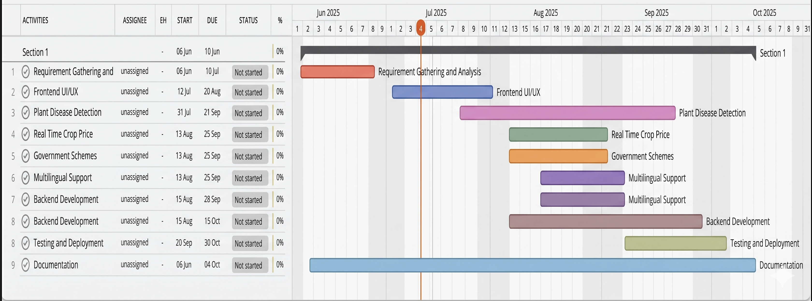
Gantt Chart

Figure 6 Gantt Chart

Chapter 3

SYSTEM DESIGN

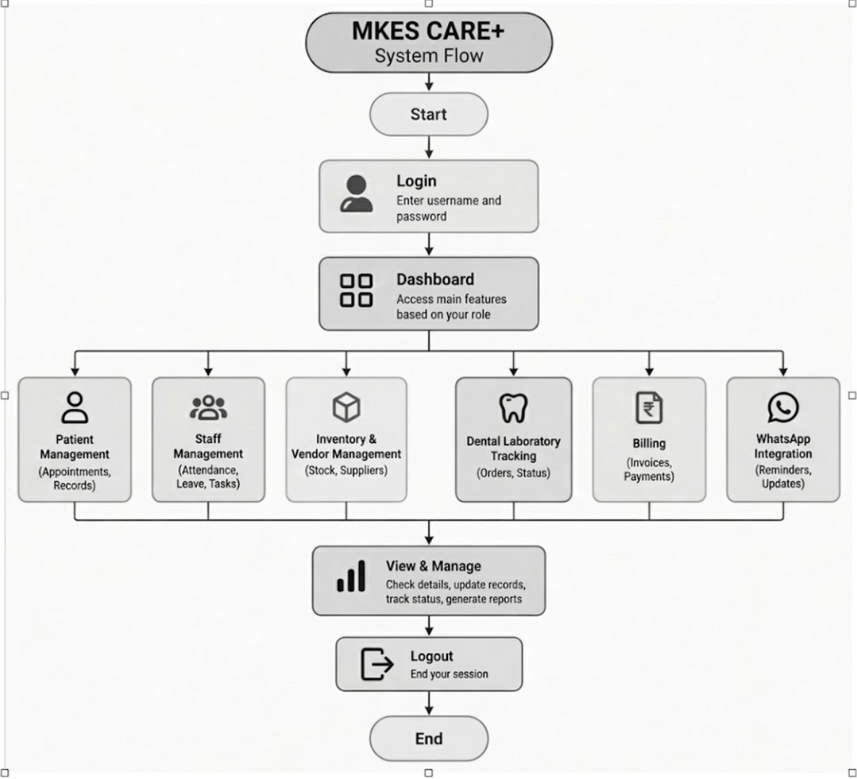
1.1 Flowchart

Figure 7 Flow Chart

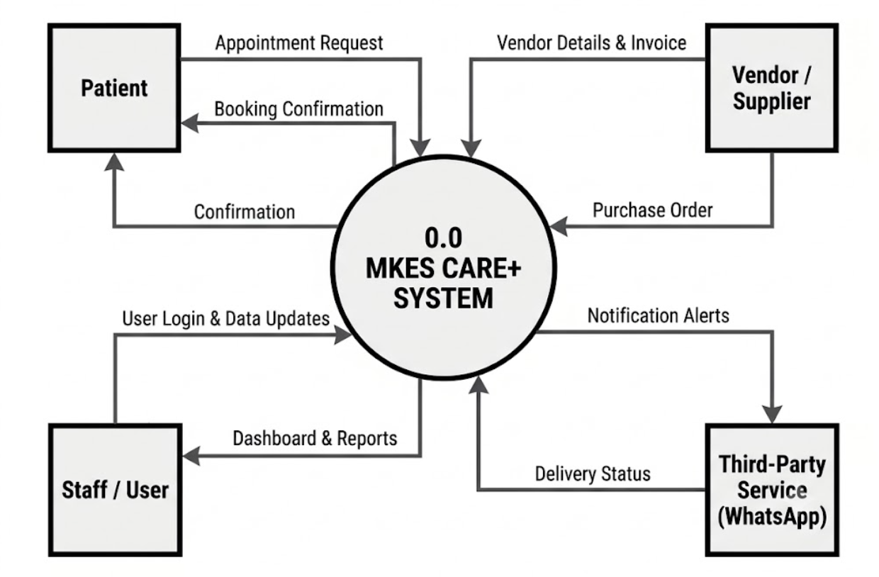
    - DFD Level 0:

Figure 8 Level 0 DFD

    - DFD Level 1:

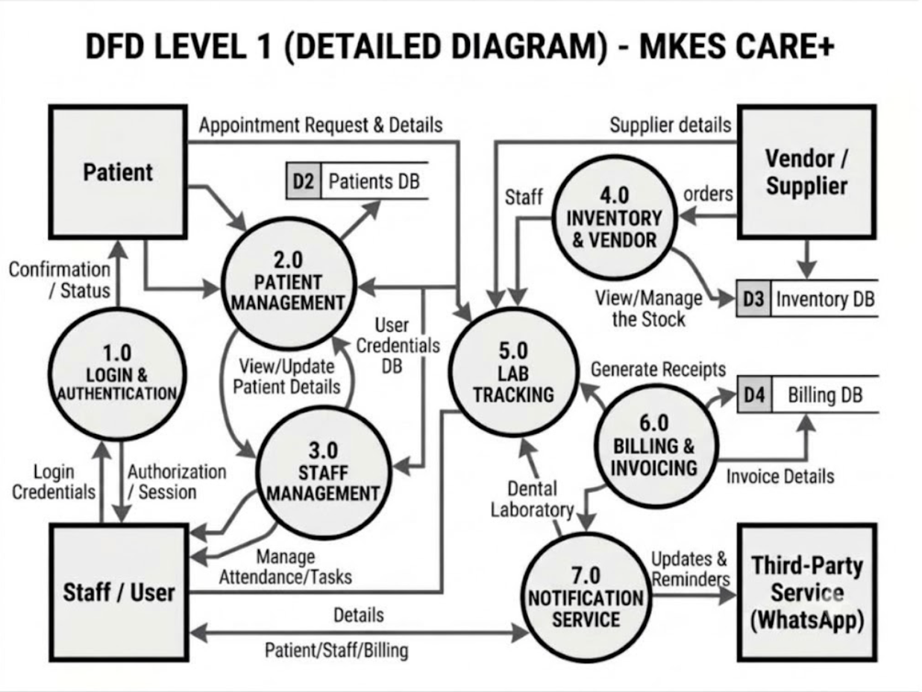

Figure: 9 Level 1 DFD

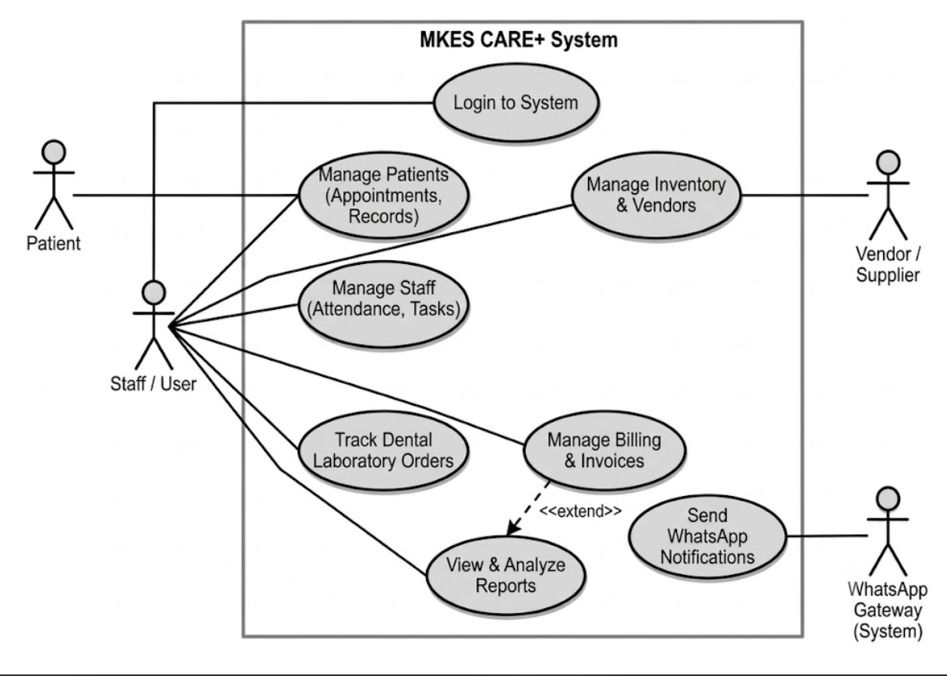

    - Use Case Diagram

Figure 10 Use case Diagram

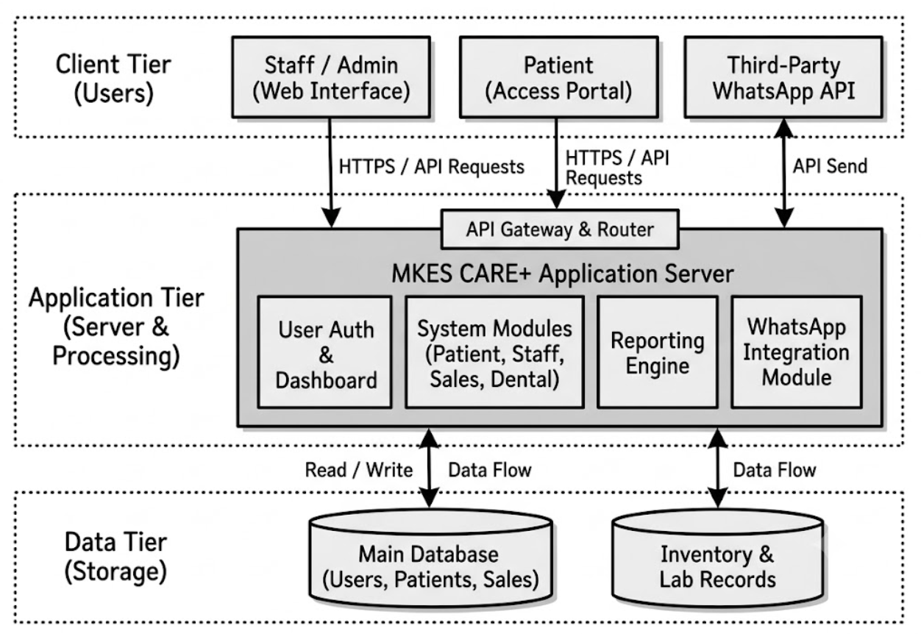
    - Basic Architecture:

Figure 11: Basic Architecture

Chapter 4

Literature Review
      - Clinic Management Systems: Clinic management systems play an important role in improving healthcare administration by digitizing routine activities and centralizing essential information. Traditional methods of managing patient records, appointments, billing, and staff activities can lead to data duplication, administrative errors, delays, and difficulties in maintaining organized workflows. Modern digital systems help healthcare facilities manage their operations more efficiently by providing centralized access to information and reducing dependence on paperwork. Eye and dental clinics require specialized management solutions because they handle different types of consultations, optical products, dental laboratory procedures, and medical supplies. MKES CARE+ addresses these requirements by integrating essential clinic operations into a unified platform. It provides role-based access for administrators, doctors, and staff, enabling users to access relevant information and perform their responsibilities efficiently. The system aims to improve coordination, simplify administrative processes, and provide a more organized approach to clinic management.

      - Patient, Appointment, and Staff Management: Patient and appointment management are essential for maintaining organized healthcare services. Digital patient management systems help clinics maintain patient details, visit histories, and department-specific records, while appointment management allows staff to schedule consultations, manage walk-in patients, and track appointment statuses and missed visits. These features help reception staff coordinate daily patient flow and reduce scheduling difficulties. Staff management is equally important for ensuring smooth clinic operations. Digital attendance systems can maintain daily and monthly attendance records, track working hours and late arrivals, and help administrators monitor employee schedules. Task management and leave management further support workforce coordination by allowing tasks to be assigned with priorities, deadlines, and completion statuses while providing a process for submitting and approving leave requests. MKES CARE+ combines patient records, appointment scheduling, attendance tracking, shift management, task assignments, leave requests, and staff history within a centralized system. These features aim to improve staff accountability, simplify daily coordination, and reduce the effort required to manage routine administrative activities.

      - Inventory, Vendor, Optical Sales, and Dental Laboratory Management: TheEffective inventory and resource management are important for ensuring the uninterrupted functioning of healthcare facilities. Clinics require regular monitoring of medicines, medical supplies, surgical lenses, contact lenses, spectacle frames, dental materials, and other essential products. Manual stock management can result in shortages, expired products, unnecessary purchases, and difficulties in tracking inventory. Digital inventory systems help maintain stock records, identify low-stock items, monitor expiry dates, and support timely replenishment. Vendor management complements these functions by maintaining supplier information and organizing purchasing requirements and follow-ups. Similarly, dental laboratory management helps staff monitor laboratory orders, identify completed work, and coordinate deliveries. MKES CARE+ integrates inventory and vendor management with optical sales and dental laboratory tracking. It supports order-status monitoring, sales records, stock alerts, and laboratory updates, helping clinic administrators maintain better control over resources, sales activities, and pending orders.

      - Billing, WhatsApp Integration, Notifications, and Reporting: Billing and financial management are important components of clinic administration because they involve invoice generation, discounts, payment records, and revenue monitoring. Manual billing processes can increase paperwork and make it difficult to maintain accurate financial information. Digital billing systems help organize invoices, record payments through methods such as cash, UPI, and cards, and maintain information about payment status. In addition to financial management, communication plays an important role in providing timely patient services. WhatsApp integration can support appointment reminders, patient follow-ups, and notifications about spectacles and dental laboratory orders, reducing the need for staff to send every message manually. Notification systems can also help administrators monitor important activities such as low stock, leave requests, pending tasks, and upcoming appointments. Dashboards and reports provide an overview of clinic operations, including patient activity, staff attendance, inventory, optical sales, and revenue. MKES CARE+ brings these capabilities together through billing and invoice management, WhatsApp-based communication, operational notifications, and daily, weekly, and monthly reporting. These features aim to improve information accessibility, reduce repetitive work, and support informed administrative decisions.

      - Technology Stack and Integrated Clinic Management: Modern clinic management applications use cross-platform development frameworks and backend database services to centralize information and support access across different devices. Flutter enables the development of applications for multiple platforms using a shared codebase, while Supabase and PostgreSQL support backend services, data storage, and structured information management. These technologies can help build scalable applications that organize clinic records and support coordinated workflows. MKES CARE+ is developed using Flutter, with Supabase and PostgreSQL supporting its backend and structured data management. By integrating patient management, appointment scheduling, staff coordination, inventory monitoring, optical sales, dental laboratory tracking, billing, reporting, and WhatsApp communication, MKES CARE+ aims to provide a unified solution for eye and dental clinic operations. The application focuses on reducing manual workload, improving coordination, centralizing information, and supporting efficient administrative management.

Source Code
Detect_disease.dart
import 'dart:convert'; import 'dart:io';
import 'package:flutter/material.dart'; import 'package:http/http.dart' as http;
import 'package:image_picker/image_picker.dart';
class PlantDiseaseDetection extends StatefulWidget { @override
_PlantDiseaseDetectionState createState() =>
_PlantDiseaseDetectionState();
}
class _PlantDiseaseDetectionState extends State<PlantDiseaseDetection>
{
File? _image;
String _result = "Upload an image to detect disease";

Future<void> _pickImage() async {
final pickedFile = await ImagePicker().pickImage(source: ImageSource.gallery);
if (pickedFile != null) { setState(() {
_image = File(pickedFile.path);
});
_uploadImage();
}
}
Future<void> _uploadImage() async { if (_image == null) return;

var request = http.MultipartRequest(

'POST',
Uri.parse('http://192.168.0.106:5000/predict'), // Local IP
);
request.files.add(await http.MultipartFile.fromPath('file',
_image!.path));
var response = await request.send(); if (response.statusCode == 200) {
var jsonResponse = jsonDecode(await response.stream.bytesToString());
var info = jsonResponse['info'];
setState(() {
_result = '''
${jsonResponse['result'] ?? ""}
Disease: ${jsonResponse['disease'] ?? "N/A"}

Description: ${info?['description'] ?? "N/A"} Cause: ${info?['cause'] ?? "N/A"} Prevention: ${info?['prevention'] ?? "N/A"} Remedies: ${info?['remedies'] ?? "N/A"}
''';
});
} else { setState(() {
_result = "Error: Could not analyze image";
});
}
}

@override
Widget build(BuildContext context) { return Scaffold(
appBar: AppBar(title: Text('Krishifala - Plant Disease Detection')), body: SingleChildScrollView(
child: Column(

mainAxisAlignment: MainAxisAlignment.center, children: [
SizedBox(height: 30),
_image != null
? Image.file(_image!, height: 200)
: Icon(Icons.image, size: 100), SizedBox(height: 20), ElevatedButton(
onPressed: _pickImage, child: Text("Select Image"),
),
SizedBox(height: 20), Padding(
padding: const EdgeInsets.all(16.0), child: Text(
_result,
textAlign: TextAlign.left, style: TextStyle(fontSize: 16),
),),],),),);}}
sell_produce_screen.dart
import 'package:flutter/material.dart';
import 'package:cloud_firestore/cloud_firestore.dart'; import 'package:firebase_auth/firebase_auth.dart';
import 'package:shared_preferences/shared_preferences.dart';
class SellProduceScreen extends StatefulWidget { @override
_SellProduceScreenState createState() => _SellProduceScreenState();
}

class _SellProduceScreenState extends State<SellProduceScreen> { final TextEditingController produceNameController =
TextEditingController();
final TextEditingController quantityController = TextEditingController(); final TextEditingController priceController = TextEditingController(); String selectedUnit = 'kg';

String? userName; String? userLocation;
final List<String> units = ['kg', 'litre', 'piece']; @override
void initState() {
super.initState(); fetchUserData();
}

Future<void> fetchUserData() async {
SharedPreferences prefs = await SharedPreferences.getInstance(); setState(() {
userName = prefs.getString('first_name') ?? ''; userLocation = prefs.getString('location') ?? '';
});
}
Future<void> postProduce() async {
if (produceNameController.text.isNotEmpty && quantityController.text.isNotEmpty && priceController.text.isNotEmpty) {
User? user = FirebaseAuth.instance.currentUser; if (user != null) {
await FirebaseFirestore.instance.collection("produce").add({ 'produce_name': produceNameController.text,
'quantity': quantityController.text, 'price': priceController.text,
'unit': selectedUnit, 'user_name': userName, 'user_location': userLocation, 'user_id': user.uid,
'timestamp': FieldValue.serverTimestamp(),
});

ScaffoldMessenger.of(context).showSnackBar( SnackBar(content: Text("Produce added successfully!")),
);

produceNameController.clear(); quantityController.clear(); priceController.clear();
} else { ScaffoldMessenger.of(context).showSnackBar( SnackBar(content: Text("User not authenticated!")),
);
}
} else { ScaffoldMessenger.of(context).showSnackBar( SnackBar(content: Text("Please fill all fields!")),
);
}
}
@override
Widget build(BuildContext context) { return Scaffold(
backgroundColor: Color(0xFFF0FFF4), // Soft mint body: SafeArea(
child: Padding(
padding: const EdgeInsets.symmetric(horizontal: 20, vertical: 30), child: SingleChildScrollView(
child: Column(
crossAxisAlignment: CrossAxisAlignment.start, children: [
// Back and title Row(
children: [ IconButton(
icon: Icon(Icons.arrow_back, color: Color(0xFF88E137)), onPressed: () => Navigator.pop(context),

),
SizedBox(width: 4), Text(
"Sell Produce", style: TextStyle( fontSize: 20,
fontWeight: FontWeight.w600,
),
),
],
),
SizedBox(height: 50),
// Produce Name label("Produce Name"),
customInputField("Enter produce name", produceNameController),

// Price SizedBox(height: 20), label("Price (per unit)"),
customInputField("0.00", priceController, keyboardType: TextInputType.number),

// Quantity and Unit SizedBox(height: 20), Row(
children: [ Expanded( child: Column(
crossAxisAlignment: CrossAxisAlignment.start, children: [
label("Quantity"),
customInputField("0", quantityController, keyboardType: TextInputType.number),
],

),
),
SizedBox(width: 12), Expanded(
child: Column(
crossAxisAlignment: CrossAxisAlignment.start, children: [
label("Unit"), Container(
padding: EdgeInsets.symmetric(horizontal: 12), decoration: BoxDecoration(
color: Colors.white,
borderRadius: BorderRadius.circular(12), border: Border.all(color: Colors.grey.shade300),
),
child: DropdownButton<String>( value: selectedUnit, isExpanded: true,
underline: SizedBox(), onChanged: (value) {
setState(() => selectedUnit = value!);
},
items: units.map((unit) { return DropdownMenuItem( value: unit,
child: Text(unit),
);
}).toList(),),),],),),],),

// Post Produce Button SizedBox(height: 40), SizedBox(
width: double.infinity, child: ElevatedButton( onPressed: postProduce,
style: ElevatedButton.styleFrom(

backgroundColor: Color(0xFF88E137), // bright green padding: EdgeInsets.symmetric(vertical: 16),
shape: RoundedRectangleBorder( borderRadius: BorderRadius.circular(12),
),
),
child: Text( "Post Produce",
style: TextStyle( fontSize: 16,
fontWeight: FontWeight.bold, color: Colors.white,
),),),)],),),),),);}

Widget label(String text) { return Padding(
padding: const EdgeInsets.only(bottom: 6), child: Text(
text,
style: TextStyle(
fontWeight: FontWeight.w600, fontSize: 15,
),),);}

Widget customInputField(String hint, TextEditingController controller,
{TextInputType keyboardType = TextInputType.text}) { return TextField(
controller: controller, keyboardType: keyboardType, decoration: InputDecoration( hintText: hint,
hintStyle: TextStyle(color: Colors.grey), filled: true,
fillColor: Colors.white,
contentPadding: EdgeInsets.symmetric(horizontal: 12, vertical: 14), border: OutlineInputBorder(
borderRadius: BorderRadius.circular(12),
borderSide: BorderSide(color: Colors.grey.shade300),
),
enabledBorder: OutlineInputBorder( borderRadius: BorderRadius.circular(12),
borderSide: BorderSide(color: Colors.grey.shade300),
),),);}}
view_other_produce.dart
import 'package:flutter/material.dart';
import 'package:cloud_firestore/cloud_firestore.dart'; import 'package:url_launcher/url_launcher.dart';

class ViewOtherProduceScreen extends StatefulWidget { @override
_ViewOtherProduceScreenState createState() =>
_ViewOtherProduceScreenState();
}

class _ViewOtherProduceScreenState extends State<ViewOtherProduceScreen> {
final FirebaseFirestore _firestore = FirebaseFirestore.instance;
final TextEditingController _searchController = TextEditingController(); String _searchQuery = '';
@override
Widget build(BuildContext context) { return Scaffold(
backgroundColor: Color(0xFFF1FFF3), appBar: AppBar(
title: Text('View Produce'), backgroundColor: Colors.transparent, elevation: 0,
foregroundColor: Colors.black,
),
body: Column( children: [

16),

Padding(
padding: const EdgeInsets.symmetric(horizontal: 16, vertical: 10), child: TextField(
controller: _searchController, onChanged: (value) { setState(() {
_searchQuery = value.trim().toLowerCase();
});
},
decoration: InputDecoration( hintText: 'Search produce...', prefixIcon: Icon(Icons.search), filled: true,
fillColor: Colors.white,
contentPadding: EdgeInsets.symmetric(vertical: 12, horizontal:
border: OutlineInputBorder( borderRadius: BorderRadius.circular(12), borderSide: BorderSide.none,
),
),
),
),
Expanded(
child: StreamBuilder<QuerySnapshot>( stream: _firestore
.collection('produce')
.orderBy('timestamp', descending: true)
.snapshots(),
builder: (context, snapshot) {
if (snapshot.connectionState == ConnectionState.waiting) { return Center(child: CircularProgressIndicator());

}
if (!snapshot.hasData || snapshot.data!.docs.isEmpty) { return Center(child: Text('No produce available.'));
}
final allProduce = snapshot.data!.docs;
final filteredProduce = allProduce.where((doc) { final data = doc.data() as Map<String, dynamic>; final name = (data['produce_name'] ??
'').toString().toLowerCase();
return name.contains(_searchQuery);
}).toList();
if (filteredProduce.isEmpty) {
return Center(child: Text('No matching produce found.'));
}

dynamic>;

dynamic>?;

return ListView.builder(
padding: EdgeInsets.symmetric(horizontal: 16, vertical: 10), itemCount: filteredProduce.length,
itemBuilder: (context, index) {
final produce = filteredProduce[index].data() as Map<String, final userId = produce['user_id'];
return FutureBuilder<DocumentSnapshot>(
future: _firestore.collection('user').doc(userId).get(), builder: (context, userSnapshot) {
final userData = userSnapshot.data?.data() as Map<String,

final phone = userData?['mobile_number'] ?? 'No phone'; final email = userData?['email'] ?? 'No email';

return Container(
margin: EdgeInsets.only(bottom: 16), padding: EdgeInsets.all(16), decoration: BoxDecoration(
color: Colors.white,
borderRadius: BorderRadius.circular(16),
),
child: Column(
crossAxisAlignment: CrossAxisAlignment.start, children: [
Text(
produce['produce_name'] ?? 'Produce', style: TextStyle(
fontSize: 18,
fontWeight: FontWeight.bold,
),
),
SizedBox(height: 4), Text(
"₹${produce['price']} / ${produce['unit']}",
style: TextStyle( fontSize: 16,
fontWeight: FontWeight.bold, color: Colors.green,
),
),
SizedBox(height: 4), Text(
"${produce['quantity']} ${produce['unit']} available", style: TextStyle(color: Colors.grey[700]),
),
Divider(height: 24), Text(
"Farmer Details",
style: TextStyle(fontWeight: FontWeight.bold),
),
SizedBox(height: 8),
Text(produce['user_name'] ?? 'Name not available'), SizedBox(height: 4),
Row( children: [
Icon(Icons.phone, size: 16),

SizedBox(width: 5), Text(phone),
],
),
SizedBox(height: 4), Row(
children: [
Icon(Icons.email, size: 16),
SizedBox(width: 5), Text(email),
],
),
SizedBox(height: 4), Row(
children: [
Icon(Icons.location_on, size: 16),
SizedBox(width: 5), Text(produce['user_location'] ?? 'No location'),
],
),
SizedBox(height: 12), ElevatedButton(
style: ElevatedButton.styleFrom( backgroundColor: Color(0xFF88E137), minimumSize: Size.fromHeight(40), shape: RoundedRectangleBorder( borderRadius: BorderRadius.circular(10),
),
),
onPressed: () async {
final Uri phoneUri = Uri(scheme: 'tel', path: phone); if (await canLaunchUrl(phoneUri)) {
await launchUrl(phoneUri);
} else { ScaffoldMessenger.of(context).showSnackBar( SnackBar(content: Text('Could not launch phone

dialer')),
);
}
},
child: Text("Contact"),
),],),);},);},);},),),],),);}}
market_prices.dart
import 'package:flutter/material.dart'; import 'package:http/http.dart' as http; import 'dart:convert';
import 'Chart_page.dart';
class FormPage extends StatefulWidget { const FormPage({super.key});

@override
_FormPageState createState() => _FormPageState();
}
class _FormPageState extends State<FormPage> {
final TextEditingController stateController = TextEditingController(); final TextEditingController districtController = TextEditingController(); final TextEditingController commodityController =
TextEditingController();
String apiKey = "579b464db66ec23bdd00000188aa878c0b3b446d671b267526a13150";

Future<void> fetchData(BuildContext context) async { String apiUrl =
"https://api.data.gov.in/resource/35985678-0d79-46b4-9ed6-6f13308a1d24?"
"api-key=$apiKey&format=json" "&limit=10" "&sort[Arrival_Date]=desc";

String state = stateController.text.trim(); String district = districtController.text.trim();
String commodity = commodityController.text.trim();

if (state.isNotEmpty) {
apiUrl += "&filters[State.keyword]=$state";
}
if (district.isNotEmpty) {
apiUrl += "&filters[District.keyword]=$district";
}
if (commodity.isNotEmpty) {
apiUrl += "&filters[Commodity.keyword]=$commodity";
}

try {
final response = await http.get(Uri.parse(apiUrl));

if (response.statusCode == 200) {
Map<String, dynamic> jsonResponse = json.decode(response.body);

if (jsonResponse.containsKey("records") && jsonResponse["records"] is List) {
List<Map<String, dynamic>> fetchedData = List<Map<String, dynamic>>.from(jsonResponse["records"]);
if (fetchedData.isNotEmpty) { Navigator.push(
context, MaterialPageRoute(
builder: (context) => ResultPage(data: fetchedData),
),
);
} else {
showErrorDialog(context, "No data found for the given input.");
}
} else {

showErrorDialog(context, "Invalid API response format.");
}
} else {
showErrorDialog(context, "Failed to fetch data. Status code:
${response.statusCode}");
}
} catch (e) {
showErrorDialog(context, "An error occurred: $e");
}
}

void showErrorDialog(BuildContext context, String message) { showDialog(
context: context,
builder: (ctx) => AlertDialog( title: const Text("Error"), content: Text(message), actions: [
TextButton(
onPressed: () => Navigator.pop(ctx), child: const Text("OK"),
),
],
),
);
}

@override
Widget build(BuildContext context) { return Scaffold(
backgroundColor: const Color(0xFFF1FFF6), body: SafeArea(
child: Padding(
padding: const EdgeInsets.symmetric(horizontal: 24, vertical: 50), child: SingleChildScrollView( // Add this to avoid overflow child: Column(

crossAxisAlignment: CrossAxisAlignment.start, children: [
const Text(
"Check Commodity Prices",
style: TextStyle(fontSize: 24, fontWeight: FontWeight.bold),
),
const SizedBox(height: 20), buildTextField("State", stateController,
Icons.location_on_outlined),
buildTextField("District", districtController, Icons.apartment_outlined),
buildTextField("Commodity Name", commodityController, Icons.shopping_bag_outlined),
const SizedBox(height: 24), SizedBox(
width: double.infinity, height: 50,
child: ElevatedButton(
onPressed: () => fetchData(context), style: ElevatedButton.styleFrom(
backgroundColor: const Color(0xFFD28FD0), foregroundColor: Colors.white,
shape: RoundedRectangleBorder( borderRadius: BorderRadius.circular(12),
),
),
child: const Text("Submit", style: TextStyle(fontSize: 18)),
),),],),),),),);}

Widget buildTextField(String label, TextEditingController controller, IconData icon) {
return Padding(
padding: const EdgeInsets.only(bottom: 16), child: Column(
crossAxisAlignment: CrossAxisAlignment.start, children: [

Text(label, style: const TextStyle(fontWeight: FontWeight.w500)), const SizedBox(height: 6),
TextField(
controller: controller, decoration: InputDecoration( filled: true,
fillColor: Colors.white,
hintText: "Enter ${label.toLowerCase()}", prefixIcon: Icon(icon, color: Colors.purple.shade200), border: OutlineInputBorder(
borderRadius: BorderRadius.circular(12), borderSide: BorderSide.none,
),),),],),);}}

class ResultPage extends StatefulWidget { final List<Map<String, dynamic>> data;

const ResultPage({super.key, required this.data});
@override
State<ResultPage> createState() => _ResultPageState();
}

class _ResultPageState extends State<ResultPage> { bool showChart = false;

@override
Widget build(BuildContext context) { final item = widget.data.first;

return Scaffold(
backgroundColor: const Color(0xFFF3FFFA), appBar: AppBar(
backgroundColor: const Color(0xFFF3FFFA), elevation: 0,
leading: IconButton(

icon: const Icon(Icons.arrow_back, color: Colors.black87), onPressed: () => Navigator.pop(context),
),
title: const Text( "Commodity Prices",
style: TextStyle(color: Colors.black87),
),
),
body: widget.data.isEmpty
? const Center(
child: Text("No data available",
style: TextStyle(fontSize: 18, color: Colors.black87)),

overflow

)
: SingleChildScrollView( // Added SingleChildScrollView to avoid

child: ListView( shrinkWrap: true,
padding: const EdgeInsets.all(16), children: [
Container(
width: double.infinity,
padding: const EdgeInsets.all(16),
margin: const EdgeInsets.only(bottom: 16), decoration: BoxDecoration(
color: const Color(0xFFF6EFFF), borderRadius: BorderRadius.circular(12),
),
child: Text(
"Commodity: ${item["Commodity"] ?? "N/A"}\n"
"State: ${item["State"] ?? "N/A"}\n"
"District: ${item["District"] ?? "N/A"}", style: const TextStyle(
fontSize: 18,
fontWeight: FontWeight.bold, color: Colors.black87,
),

widget.data)),

),
),
ElevatedButton.icon( onPressed: () { Navigator.push(
context,
MaterialPageRoute(builder: (context) => ChartPage(data:

);
},
icon: const Icon(Icons.show_chart), label: const Text("Show Price Trends"), style: ElevatedButton.styleFrom(
backgroundColor: Colors.deepPurple.shade200, foregroundColor: Colors.white,
shape: RoundedRectangleBorder(borderRadius:

BorderRadius.circular(12)),
),
),
const SizedBox(height: 24),
...widget.data.map((item) { return Container(
margin: const EdgeInsets.only(bottom: 16), padding: const EdgeInsets.all(16), decoration: BoxDecoration(
color: Colors.white,
borderRadius: BorderRadius.circular(16), boxShadow: [
BoxShadow(
color: Colors.black.withOpacity(0.05), blurRadius: 6,
offset: const Offset(2, 2),
)
],
),
child: Column(

children: [ Row( children: [
buildPriceBox("Minimum Price",
"₹${item["Min_Price"] ?? "N/A"}"),
const SizedBox(width: 12),
buildPriceBox("Maximum Price", "₹${item["Max_Price"]

?? "N/A"}"),

"N/A"}"), "N/A"),

],
),
const SizedBox(height: 12), Row(
children: [
buildPriceBox("Modal Price", "₹${item["Modal_Price"] ??

const SizedBox(width: 12),
buildPriceBox("Last Updated", item["Arrival_Date"] ??

],),],),}).toList(),],),),);}

Widget buildPriceBox(String label, String value) { return Expanded(
child: Container(
padding: const EdgeInsets.symmetric(vertical: 16, horizontal: 12), decoration: BoxDecoration(
color: const Color(0xFFF8F8F8), borderRadius: BorderRadius.circular(12),
),
child: Column(
crossAxisAlignment: CrossAxisAlignment.start, children: [
Text(label,
style: const TextStyle( fontSize: 13,
color: Colors.black54,
)),

const SizedBox(height: 6), Text(value,
style: const TextStyle( fontSize: 18,
fontWeight: FontWeight.bold, color: Colors.black87,
)),
],
),
),
);
}
}

Snapshots
As we open Krishifala app, we are asked to sign up. There is also an option to sign in (log in) in case the account is already created. After signing in successfully, the app shows a success message to indicate the account has been created. Then the user is redirected to the login page. After the login, user is redirected to the homescreen.
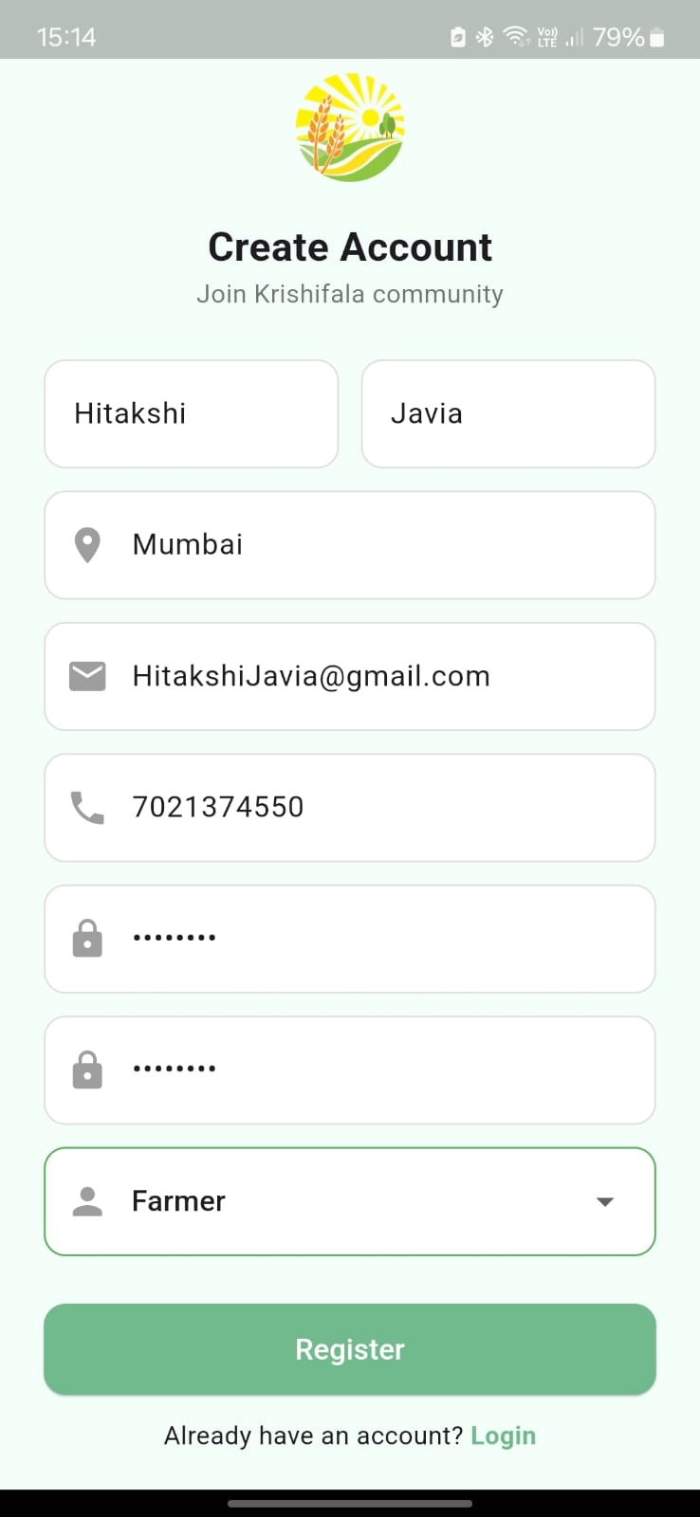
Figure 12 Sign in

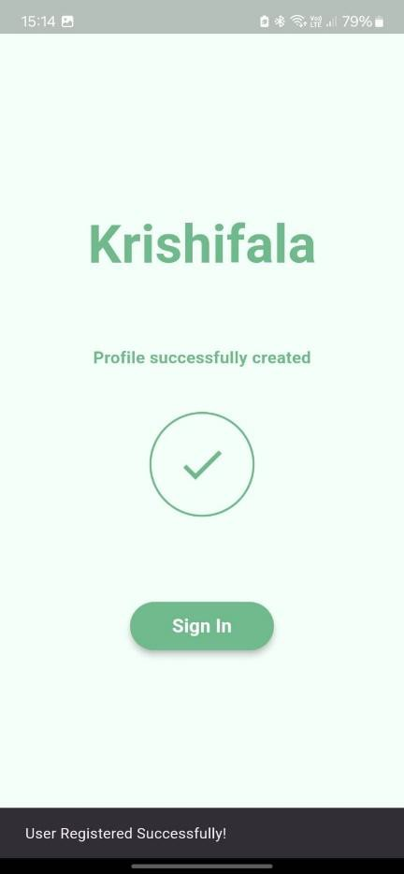
Figure 13 Successful Creation
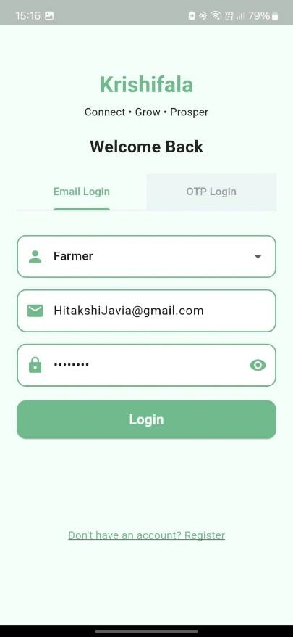
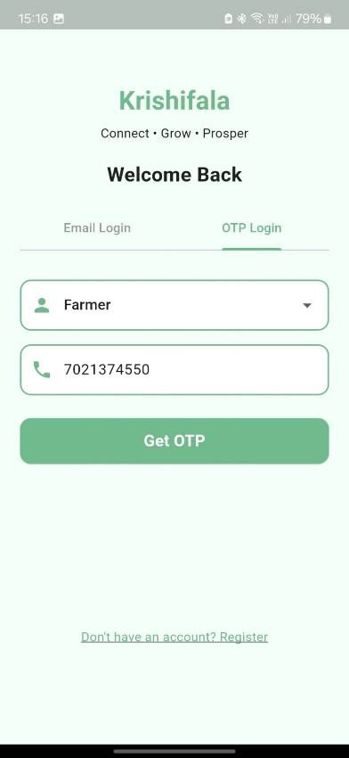
Figure 14 Email Log Figure 15 OTP Login

The home screen offers a clean dashboard with quick access to four core features: Disease Detection, Market Place, Commodity Prices, and Government Schemes. It also displays live weather info and a daily farming tip to assist users with real-time insights.

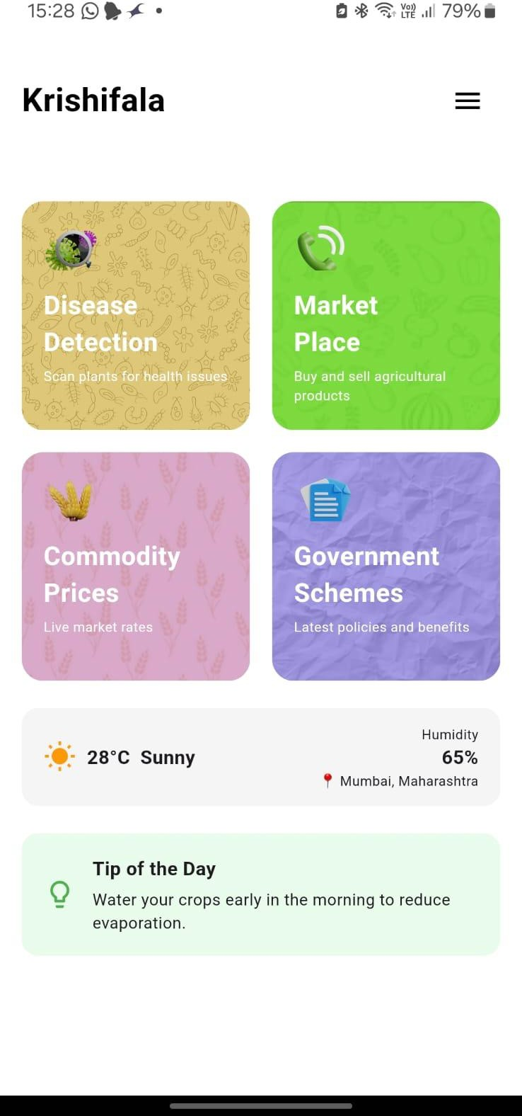
Figure 16 Home Screen

The disease detection screen allows users to upload an image from the photo gallery of their phone or take a photo. Once uploaded the image is displayed on the screen and it is analyzed by the ML model working in the backend.

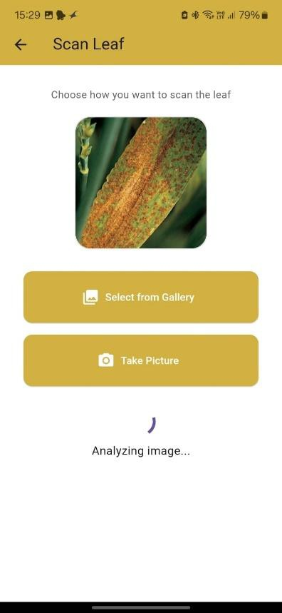
Figure 17 Disease Detection
The next page shows the results to the user. It displays information such as Effects

of the disease, its causes, remedies for the disease, and prevention techniques.

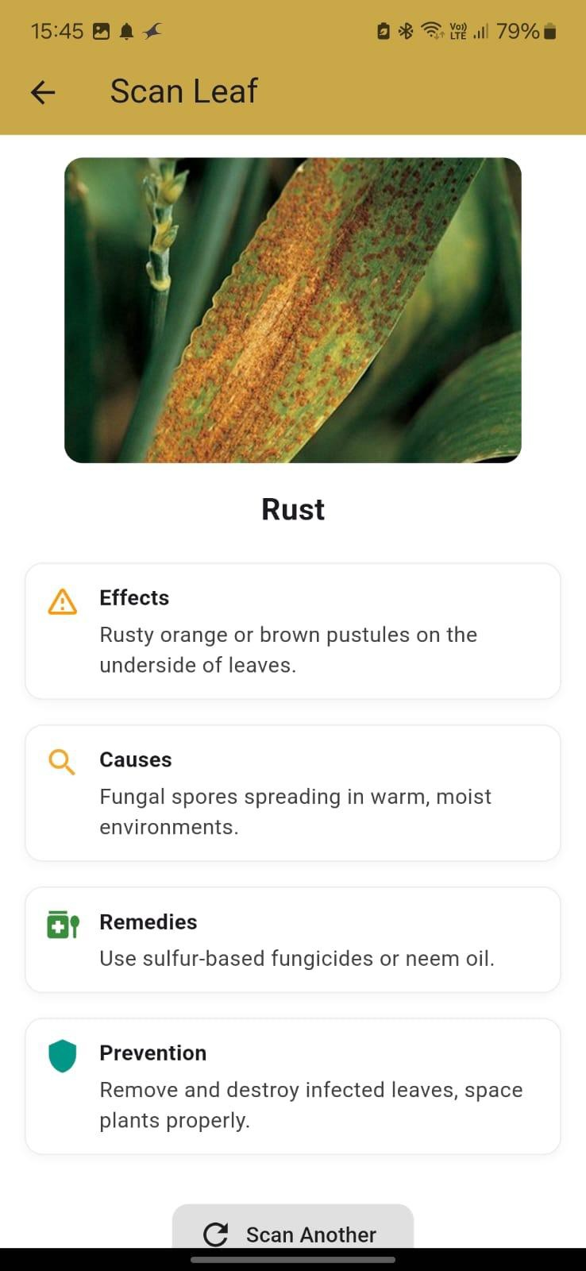
Figure 18 Detected Disease

The market allows farmer to post their produce, view the produce posted by the farmer, and view the produce that other farmers have posted.

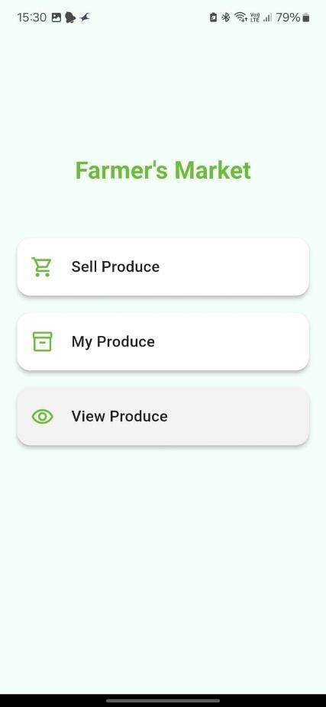
Figure 19 Farmer's Market

This screen allows farmers to post their produce by entering the produce details.

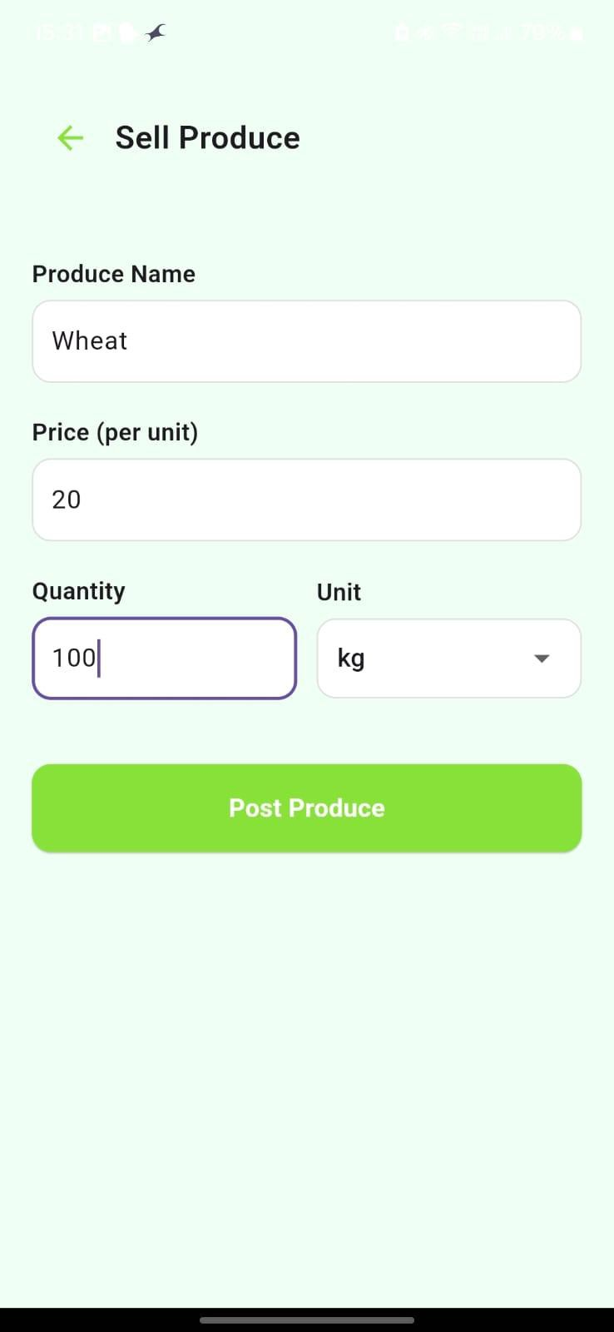
Figure 20 Sell Produce Screen
This screen enables the farmers to view the produce that they have posted,

showing the details and also allowing them to delete the post.

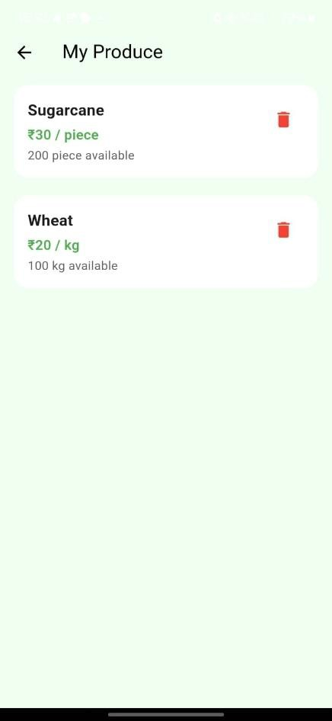
Figure 21 Farmer's produce
This screen shows buyers the produce posted by farmers. It also provides a search
functionality. When clicked on “Contact” button, it allows the buyer to call the

farmer.

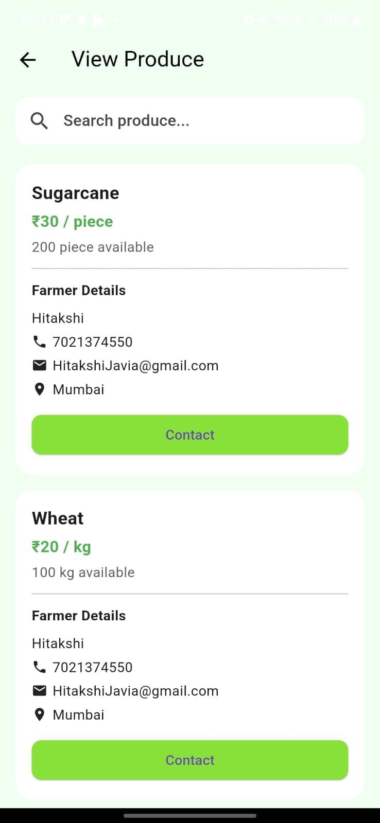
Figure 22 View Produce

This shows the search functionality.
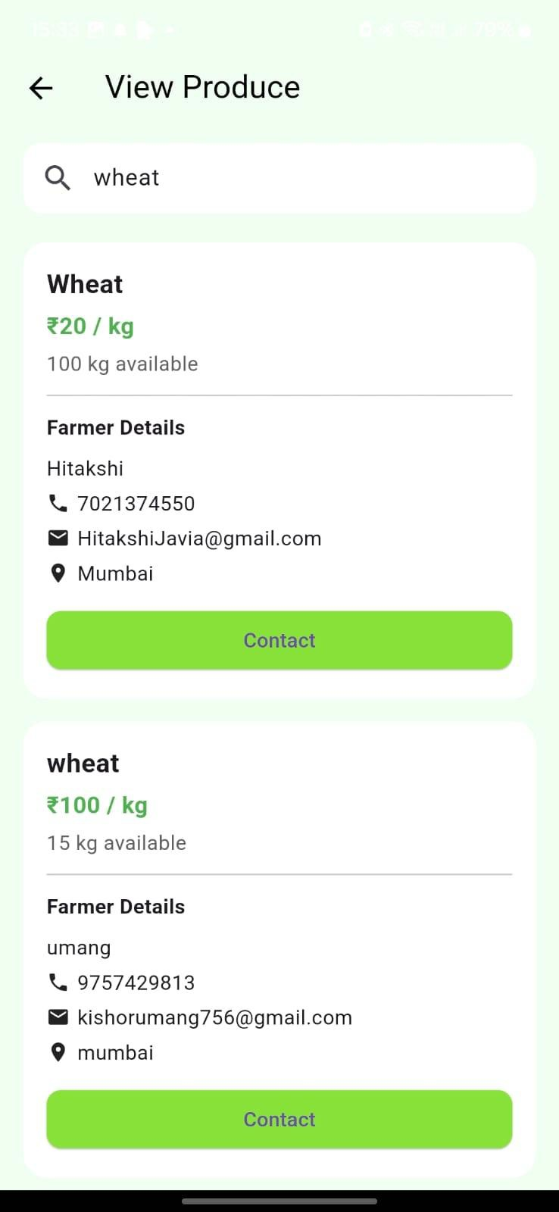
Figure 23 Search Functionality
This is the Commodity Price module that allows a user to check the price trend of

a certain commodity by their state and district.

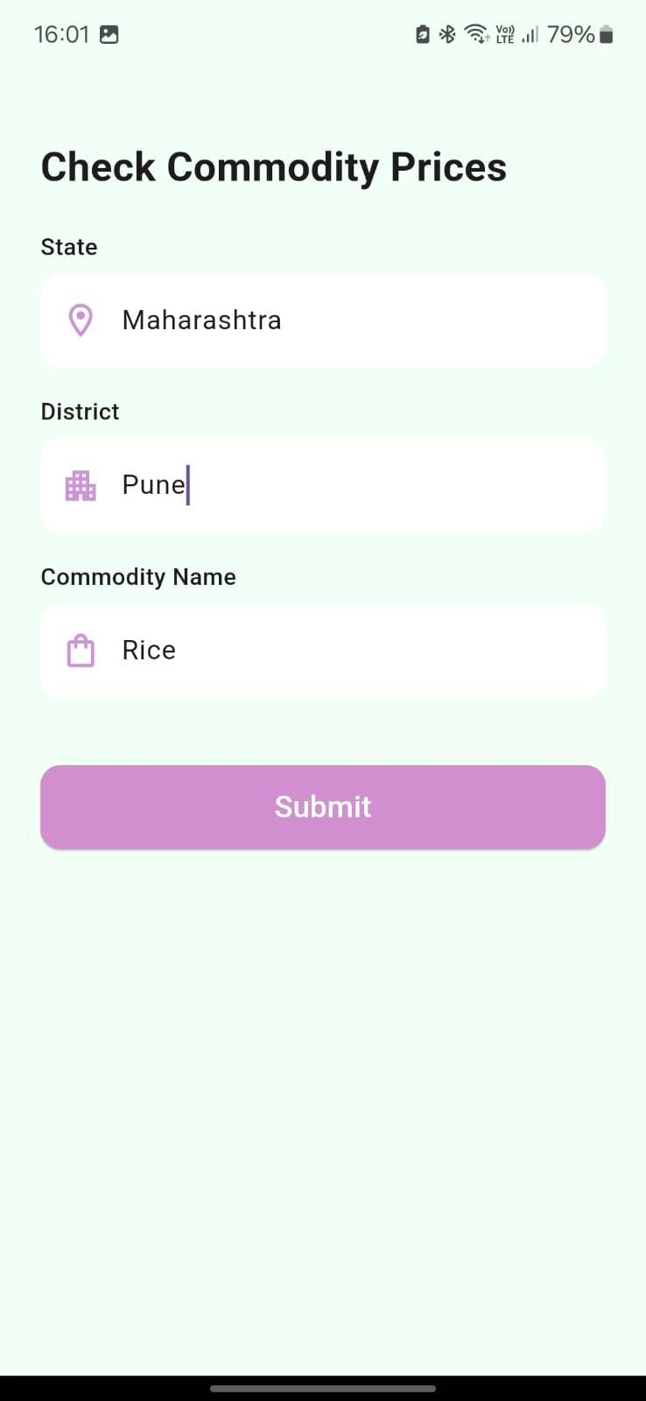
Figure 24 Commodity Prices
This screen displays the latest 10 entries of commodity prices based on the selected state, district, and crop. It shows the minimum, maximum, and modal prices along with their update dates. Tapping “Show Price Trends” opens a line

graph visualizing the price variations over time.

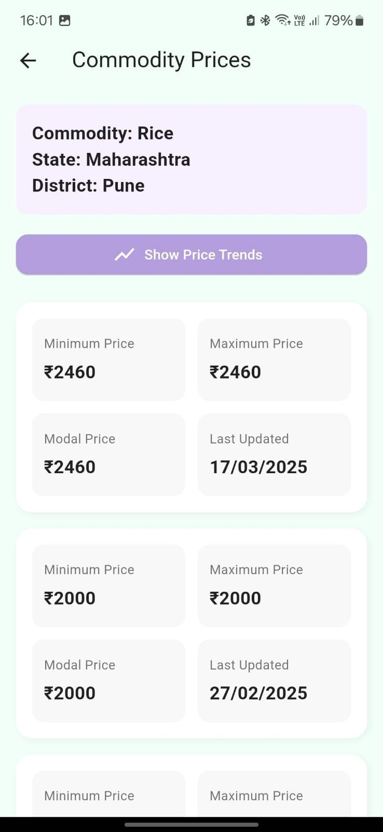
Figure 25 Viewing the prices
The government scheme module shows the various government schemes that are

beneficial for the farmers.

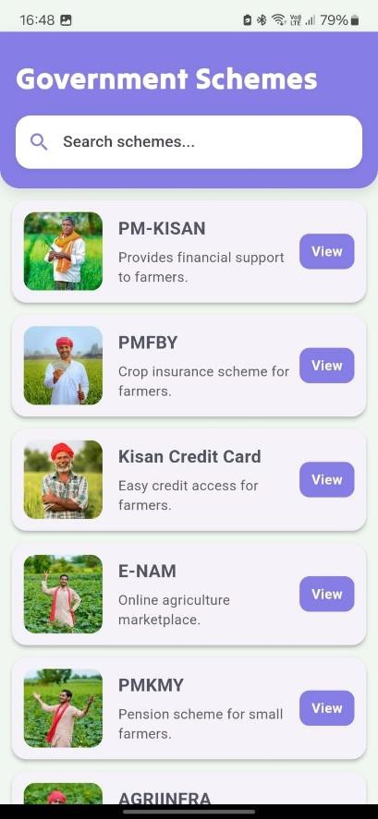
Figure 26 Government Schemes

This screen shows the search functionality of this module.
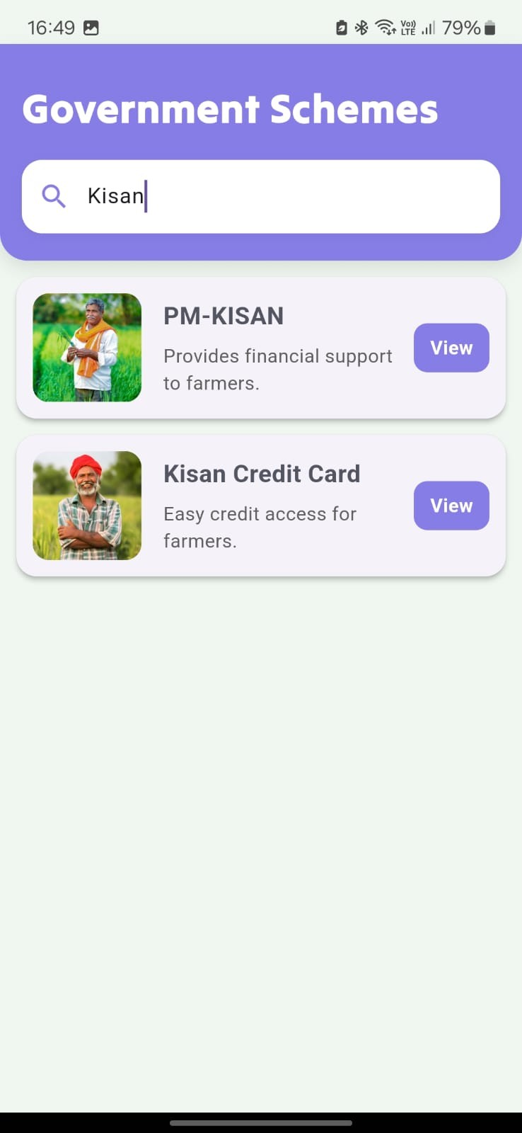
Figure 27 Searching Schemes
When the user clicks on a scheme, a brief overview, required documents, and the steps to apply are displayed, allowing the farmer to decide which scheme suits them the best. When the user clicks on “Apply”, it redirects them to the official site

to apply.
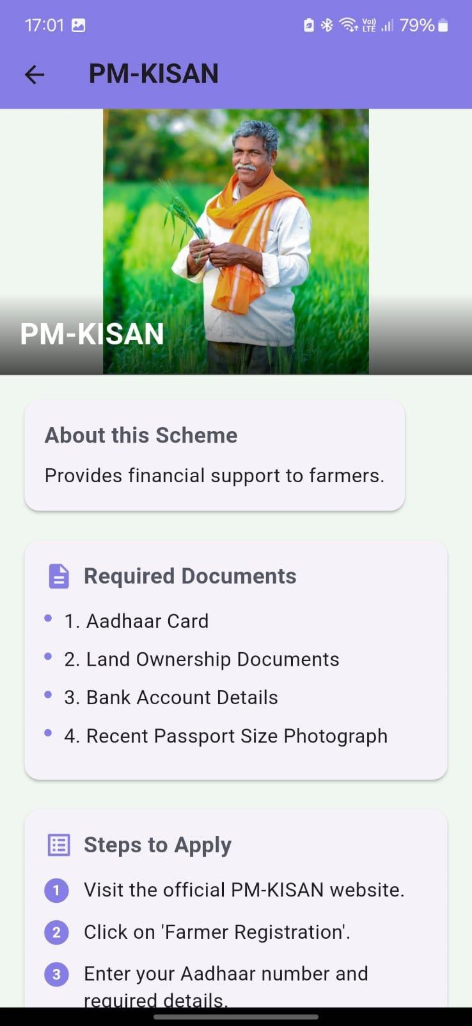
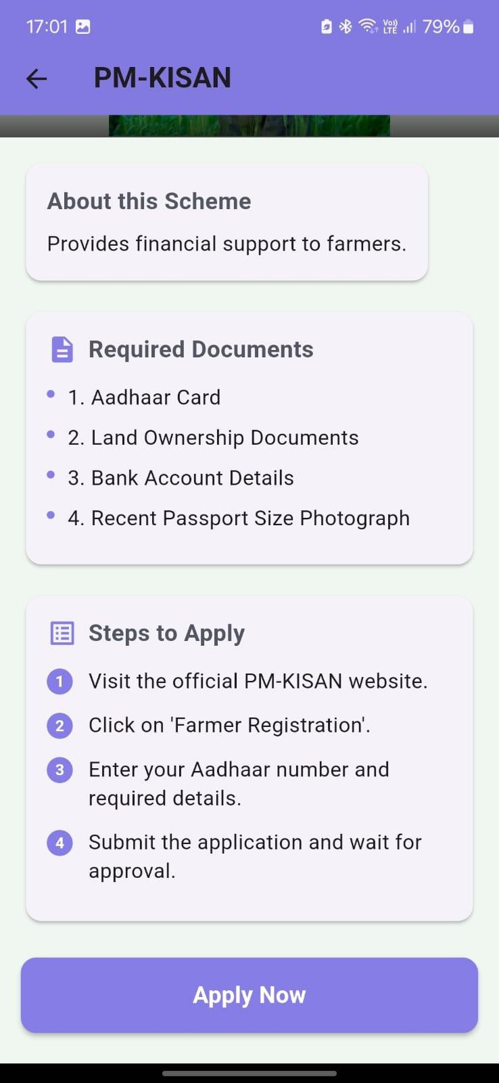
Figure 28 Government Scheme Details

The accuracy of the model:
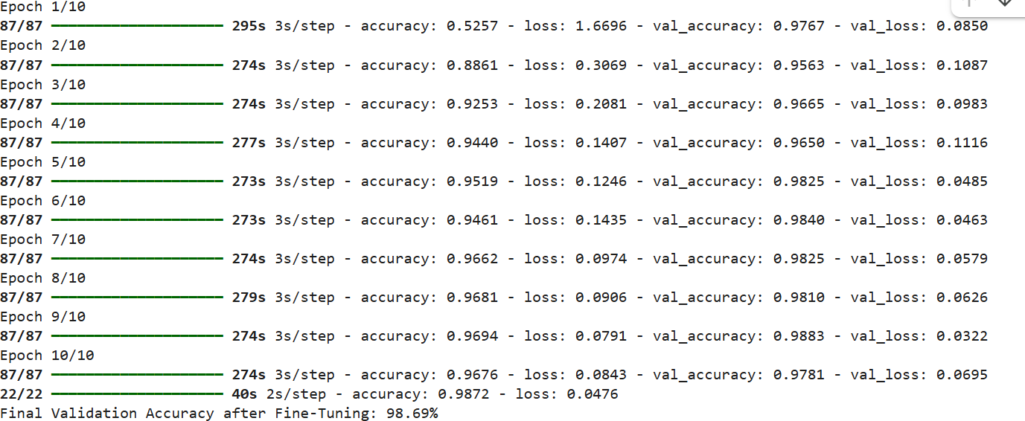
Figure 29 Model Accuracy

The “user” collection:
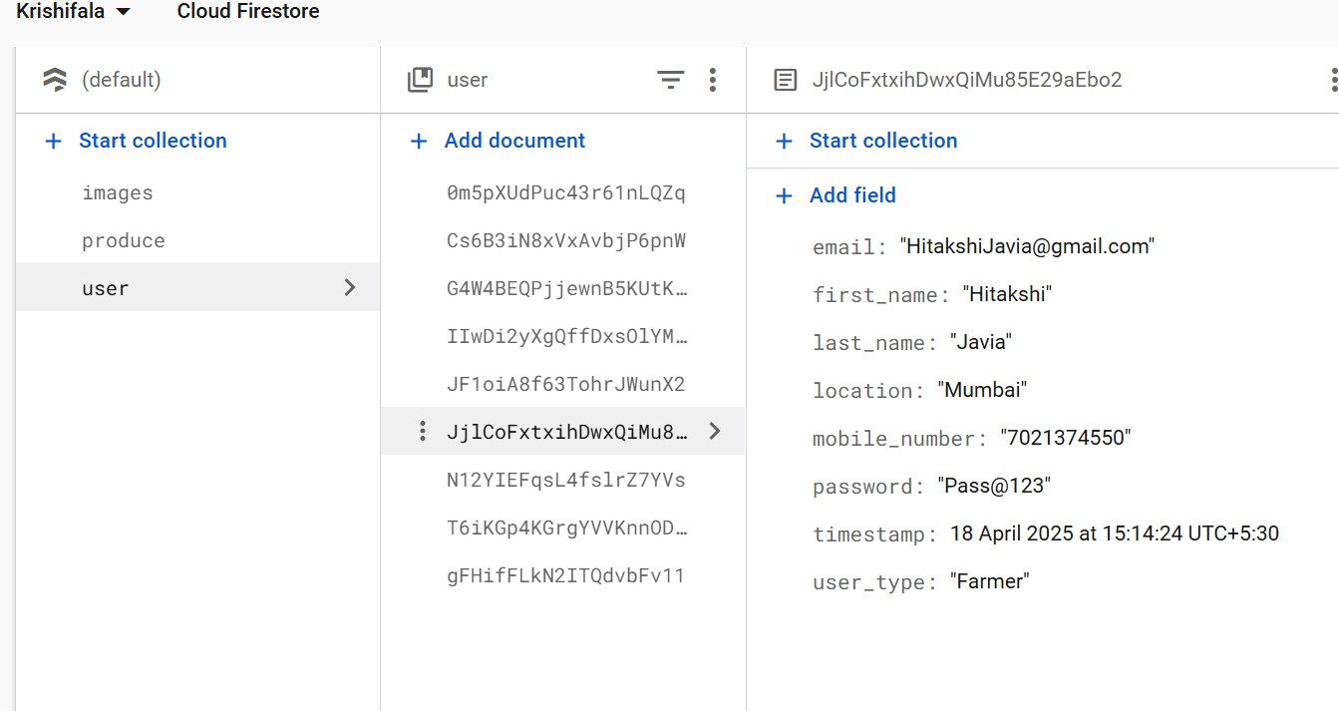
Figure 30 User Collection

The “produce” collection:
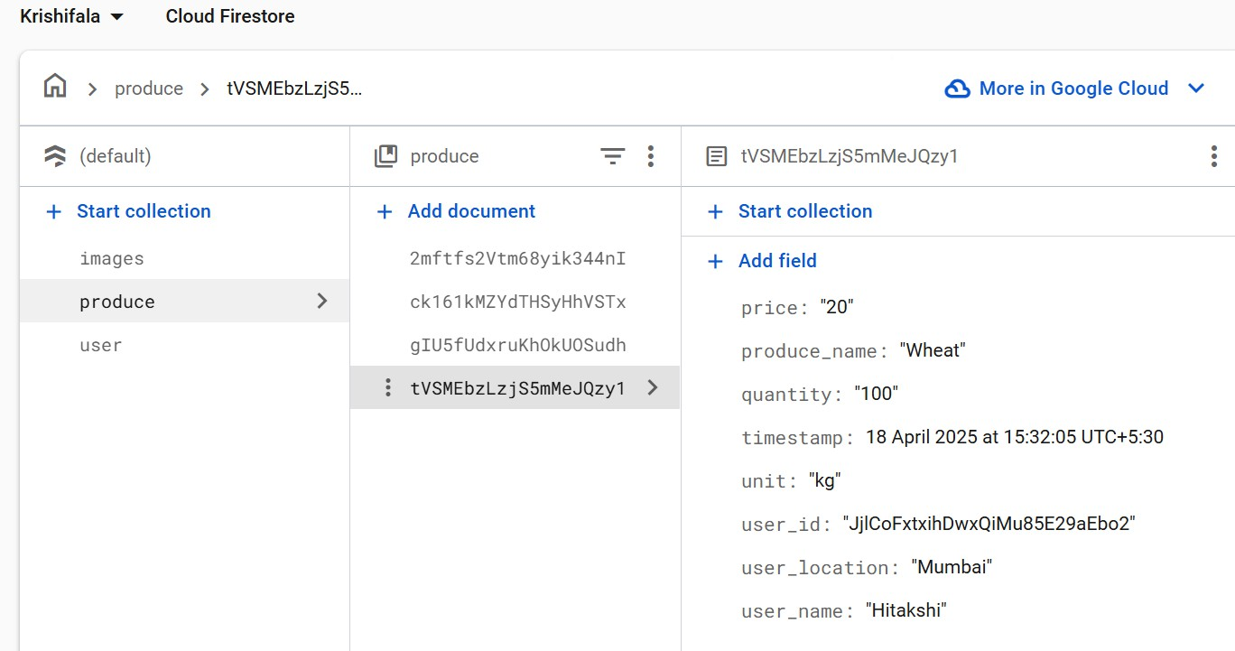
Figure 31 Produce Collection

The account screen:
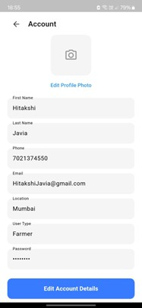
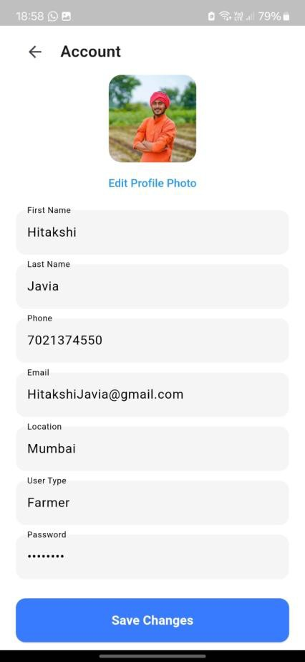
Figure 32 Account Page

The Plant Disease Dataset used for plant disease detection module:
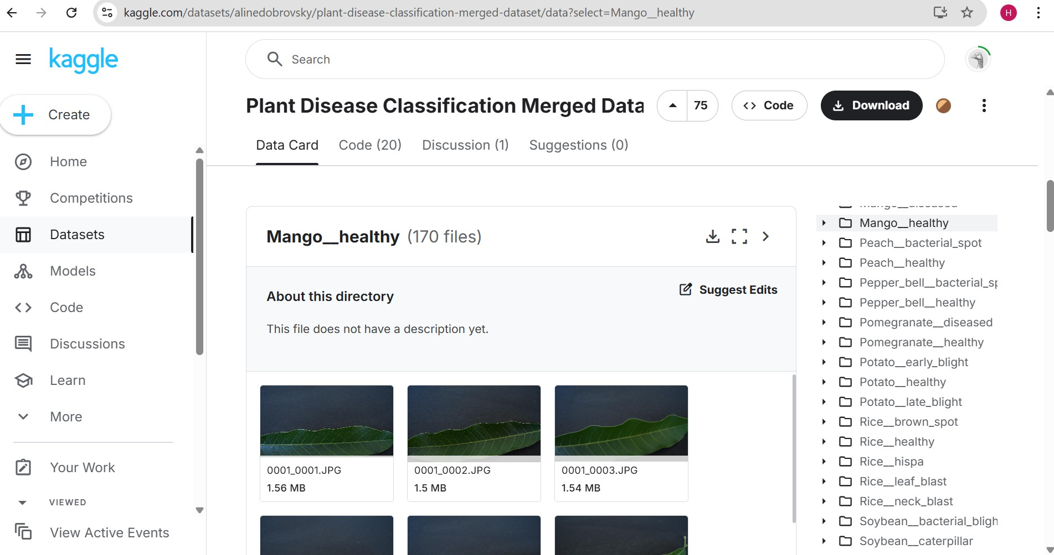
Figure 33 Plant Disease Dataset

Chapter 5

Advantages

- Centralized Management: Integrates patient records, appointments, staff, inventory, and billing into one platform.
- Improved Appointment Handling: Simplifies appointment scheduling, patient record management, and visit tracking.
- Efficient Staff Management: Helps monitor attendance, shifts, tasks, and leave requests.
- Better Inventory Control: Tracks stock levels, product expiry dates, and low-stock alerts.
- Streamlined Operations: Simplifies optical sales, spectacle orders, and dental laboratory tracking.
- Improved Communication: Supports WhatsApp notifications for appointment reminders, patient follow-ups, and order updates.
- Organized Financial Records: Simplifies invoice generation, payment tracking, and revenue monitoring.
- Enhanced Reporting and Monitoring: Provides dashboards and organized reports to help administrators review clinic activities and make informed operational decisions.

Future Scope
- Advanced Reports and Analytics: Introduce detailed reports and interactive dashboards to analyze patient visits, revenue, inventory usage, and overall clinic performance.
- Automated Patient Communication: Expand WhatsApp integration to support appointment reminders, follow-up notifications, prescription updates, and spectacle or dental order status alerts.
- Online Appointment Booking: Provide patients with an option to book, reschedule, or cancel appointments online, reducing manual coordination.
- Enhanced Inventory Management: Implement demand forecasting, automated purchase suggestions, and improved stock monitoring to reduce shortages and wastage.
- Multi-Branch Management: Extend the system to support multiple clinic branches with centralized monitoring of staff, appointments, inventory, and financial activities.
- Improved Security and Scalability: Strengthen data protection through enhanced access controls, audit logs, secure backups, and infrastructure improvements to support future growth.
- Patient Portal: Develop a dedicated portal where patients can access appointment details, billing information, and relevant medical records securely.
- Enhanced Notification System: Expand automated notifications to keep clinic administrators and staff informed about upcoming appointments, pending tasks, leave requests, inventory alerts, and important operational updates.

Limitations
- Internet Dependency: The application requires a stable internet connection for accessing cloud-based services and synchronizing data with the backend.
- WhatsApp Integration Dependency: WhatsApp notifications and automation depend on the availability and compatibility of the integration service and WhatsApp platform.
- Platform Compatibility: Application performance and feature availability may vary across devices, operating systems, and screen sizes. Thorough testing is required to ensure a consistent user experience.
- Data Security and Privacy: Since the system manages sensitive patient and clinic information, continuous security improvements, access control, and regular backups are necessary.
- Dependence on Accurate Data Entry: The reliability of reports, inventory records, billing information, and operational insights depends on the accuracy and completeness of the data entered by users.
- Limited Integration with External Systems: Integration with external hospital systems, laboratory platforms, payment gateways, or other healthcare services may require additional development.
- Initial Setup and Training: New users may require initial training and guidance to understand the application's modules and use its features.

Acknowledgement

We are pleased to present our project “MKES CARE+” and would like to take this opportunity to express our sincere gratitude to everyone who contributed to the successful completion of this work.
We extend our heartfelt thanks to our college for providing the necessary infrastructure, guidance, and a supportive environment throughout the duration of the project. The availability of resources, laboratories, and technical facilities played an important role in helping us develop and implement our project successfully.
We are especially grateful to the teaching and non-teaching staff, as well as the laboratory assistants, for their cooperation and assistance whenever we required access to systems, software, and other technical resources.
We would like to express our deepest gratitude to our project guide, Mrs. Krishna Bhatt, for her continuous support, valuable guidance, insightful feedback, and encouragement throughout the development of MKES CARE+. Her timely suggestions, patience, and motivation helped us remain focused and overcome challenges during the various stages of the project. Her guidance and support encouraged us to explore ideas and develop a practical solution for improving clinic management and administrative operations.
Lastly, we would like to thank all the individuals who supported us, directly or indirectly, during the course of this project. Their cooperation, encouragement, and contributions played a valuable role in helping us complete MKES CARE+ successfully.

Conclusion
MKES CARE+ is a clinic management system developed to simplify and improve the daily operations of eye and dental clinics. It integrates essential functions such as patient management, appointment scheduling, staff attendance, task management, inventory, optical sales, dental laboratory tracking, and billing into a centralized platform. By using Flutter, Supabase, and PostgreSQL, the system provides an organized approach to managing clinic information and improving staff coordination. WhatsApp integration further supports patient communication, appointment reminders, follow-ups, and order updates. These features aim to reduce repetitive administrative work, minimize manual errors, and improve the efficiency of clinic operations. Overall, MKES CARE+ demonstrates how technology can help streamline healthcare administration and support better management of clinic activities. Future enhancements, including advanced reporting capabilities, online appointment booking, improved inventory management, and multi-branch support, could further expand the system's functionality and make it a more comprehensive solution for modern eye and dental clinics.

References

- Flutter, “Flutter Documentation.” [Online]. Available: https://docs.flutter.dev/
- Supabase, “Supabase Documentation.” [Online]. Available: https://supabase.com/docs
- PostgreSQL Global Development Group, “PostgreSQL Documentation.” [Online]. Available: https://www.postgresql.org/docs/
- Supabase, “Use Supabase with Flutter.” [Online]. Available: https://supabase.com/docs/guides/getting-started/quickstarts/flutter
- P. Zhao, I. Yoo, J. Lavoie, B. J. Lavoie, and E. Simoes, “Web-Based Medical Appointment Systems: A Systematic Review,” Journal of Medical Internet Research, vol. 19, no. 4, p. e134, 2017. doi: 10.2196/jmir.6747. [Online]. Available: https://doi.org/10.2196/jmir.6747
- A. Ala and F. Chen, “Appointment Scheduling Problem in Complexity Systems of the Healthcare Services: A Comprehensive Review,” Journal of Healthcare Engineering, vol. 2022, article 5819813, 2022. doi: 10.1155/2022/5819813. [Online]. Available: https://doi.org/10.1155/2022/5819813
- E. Saha and P. K. Ray, “Modelling and analysis of inventory management systems in healthcare: A review and reflections,” Computers & Industrial Engineering, vol. 137, article 106051, 2019. doi: 10.1016/j.cie.2019.106051. [Online]. Available: https://doi.org/10.1016/j.cie.2019.106051
- Q. Nguyen, M. Wybrow, F. Burstein, D. Taylor, and J. Enticott, “Understanding the impacts of health information systems on patient flow management: A systematic review across several decades of research,” PLOS ONE, vol. 17, no. 9, e0274493, 2022. doi: 10.1371/journal.pone.0274493. [Online]. Available: https://doi.org/10.1371/journal.pone.0274493

- World Health Organization, Global Strategy on Digital Health 2020–2025. Geneva, Switzerland: WHO, 2021. ISBN: 978-92-4-002092-4. [Online]. Available: https://www.who.int/publications/i/item/9789240020924
- wwebjs, “whatsapp-web.js: A WhatsApp Client Library for Node.js.” GitHub repository. [Online]. Available: https://github.com/wwebjs/whatsapp-web.js
- Dart Team, “Dart Documentation.” [Online]. Available: https://dart.dev/guides
- PostgreSQL Global Development Group, “What Is PostgreSQL?” [Online]. Available: https://www.postgresql.org/docs/current/intro-whatis.html
- Google, “Google Search.” [Online]. Available: https://www.google.com/
- Google, “Gemini — AI Assistant.” [Online]. Available: https://gemini.google.com/
- Google, “Google Cloud Documentation.” [Online]. Available: https://cloud.google.com/docs

